# **String Functions Assignment**

**Mandatory**

1. **WAP to prompt and read a line of text with words separated by space. Tokenise and extract the words. Display them. Impement the following functions for this.**
   1. int tokenise(char *arr); //tokenise and display tokens , return number of tokens to the caller

[Use strtok() to tokenise]

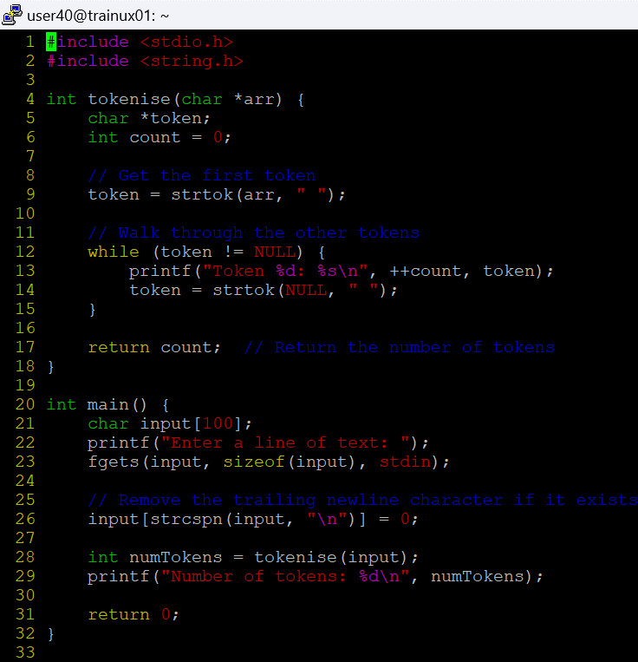

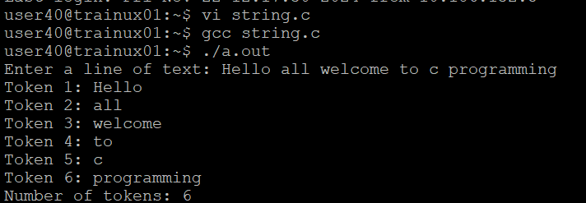

**2.)Implement your own strncat() which shall concatenate n characters from src to dest.**

**char *strncat(char *dest, const char *src, size_t n)**

**3.)WAP to**

**a.** Search for and replace the vowel characters (upper and lower case) with “ay” in a word read from user. Consider a maximum word length of 40 characters.

b.)Identify the test inputs to be used

c.)Display updated string

